Product Dozen Display
User Manual
A L P H A L I Z E T E C H N O L O G I E S
Product Dozen Display
An Odoo 19 add-on that lets you view and enter a product's on-hand stock in dozens (with a configurable pack size) as “X Dozen Y Pcs” — on the product form, the products list, and inventory adjustments.
Module | Version | Platform | Audience
product_dozen_display | 19.0.1.0.0 | Odoo 19 | Inventory / stock managers

Contents
1. Introduction 1
1.1 What the module adds 1
1.2 How it works 1
1.3 Module summary 1
2. Installation 1
2.1 Prerequisites 1
2.2 Deploy the module files 1
2.3 Install from the Apps menu 1
2.4 Verify the installation 1
3. The Dozen Fields 1
4. Using the Module 1
4.1 Enable Dozen Display on a product 1
4.2 Set Pieces per Dozen 1
4.3 Enter the on-hand quantity in dozens 1
4.4 Read the on-hand breakdown 1
4.5 Count in dozens during an inventory adjustment 1
5. Troubleshooting 1
6. Frequently Asked Questions 1
Appendix A: Quick Reference 1
Where to find things 1
At a glance 1

1. Introduction
Product Dozen Display is a small Odoo 19 add-on for shops that buy or sell items in dozens but track them as single pieces. It shows the on-hand quantity broken into full dozens plus the loose remainder (for example, 115 on hand becomes “9 Dozen 7 Pcs”), and it lets a stock manager type the on-hand quantity in dozens instead of pieces.
The “dozen” size is configurable per product — by default 12, but you can set any pack size (for example 6 or 15). The module never changes how Odoo stores stock; it only adds a friendlier way to read and enter the same Quantity On Hand.

1.1 What the module adds
- A per-product Dozen Display toggle on the product form that turns the feature on for that product.
- A Pieces per Dozen setting (default 12) that controls every dozen conversion for the product.
- An editable On Hand (Dozens) field — type the stock in dozens and Quantity On Hand fills in automatically.
- Read-only On Hand (Dozen + Pcs) and On Hand (Pieces) fields showing the same stock two ways.
- A Counted (Dozens) column on the inventory-adjustment screen, so physical counts can be entered in dozens.
- On install, it activates the built-in Dozens unit and enables the Units of Measure feature.

1.2 How it works
Quantity On Hand stays the single source of truth. The module simply converts between pieces and dozens using the product's Pieces per Dozen value:
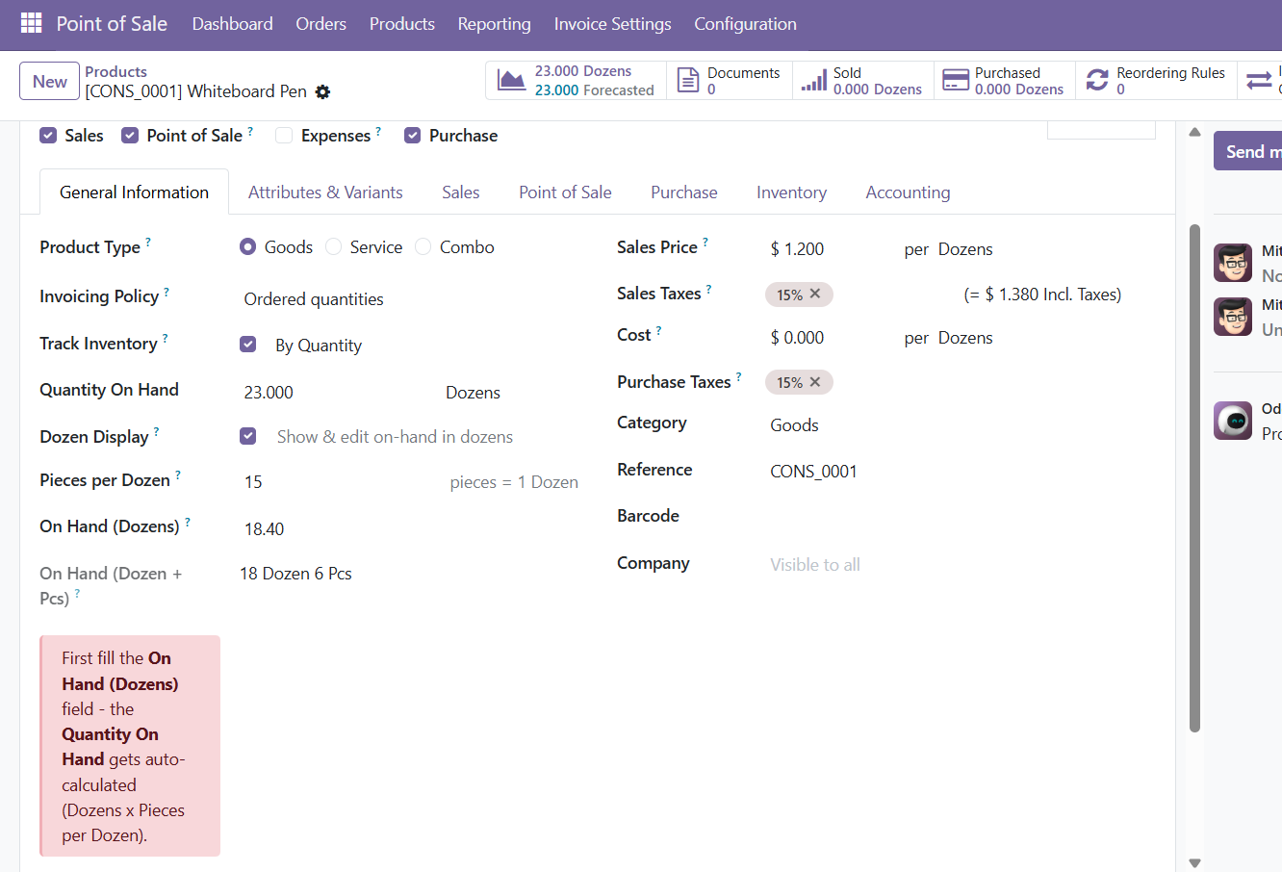
Figure 1: The dozen fields on the product form — the on-hand stock shown as full dozens plus loose pieces (18 Dozen 6 Pcs with a 15-piece pack).
NOTE The dozen fields apply to countable products — those measured in the Units family (single pieces, dozens, …). Weight- or volume-based products do not show them.

1.3 Module summary
Property | Value
Technical name | product_dozen_display
Display name | Product Dozen Display
Version | 19.0.1.0.0
Category | Inventory
Author | Alphalize Technologies
License | LGPL-3
Dependencies | product, stock, uom
Type | Technical add-on (extends the Product and Inventory screens)

2. Installation
Installing the module is a standard Odoo add-on deployment. You need administrator access to the Odoo server and the database.

2.1 Prerequisites
- An Odoo 19 instance you can administer.
- The Inventory app installed (the module depends on product, stock and uom).
- Server access to the add-ons directory, or permission to upload modules through the interface.

2.2 Deploy the module files
Copy the product_dozen_display folder into your Odoo add-ons directory, then restart the Odoo service so the new module is detected.

2.3 Install from the Apps menu
TIP The module is a technical add-on (not an application), so clear the Apps filter in the search bar to find it in the list.

2.4 Verify the installation
- Go to Inventory › Configuration › Units of Measure — the Dozens unit (1 Dozen = 12) is present and active.
- Open any storable product and enable Track Inventory — a Dozen Display checkbox appears under Quantity On Hand.

3. The Dozen Fields
The module adds the following fields. All of them appear only when the product is storable and Dozen Display is enabled.
Field | Where | Editable | Purpose
Dozen Display | Product form | Yes (checkbox) | Turns the dozen feature on for this product.
Pieces per Dozen | Product form | Yes (number) | How many single pieces make one dozen (default 12).
On Hand (Dozens) | Product form | Yes (number) | Type the on-hand quantity in dozens; fills Quantity On Hand.
On Hand (Dozen + Pcs) | Product form + list | No | Shows on-hand as full dozens plus loose pieces, e.g. “9 Dozen 7 Pcs”.
On Hand (Pieces) | Product form | No | Shows the on-hand as a total number of single pieces.
Counted (Dozens) | Inventory adjustment | Yes (number) | Enter a physical count in dozens; fills Counted Quantity in pieces.

4. Using the Module

4.1 Enable Dozen Display on a product
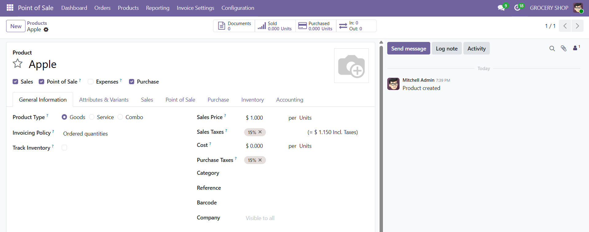
Figure 2: A newly created product — with Track Inventory off, no dozen fields are shown.
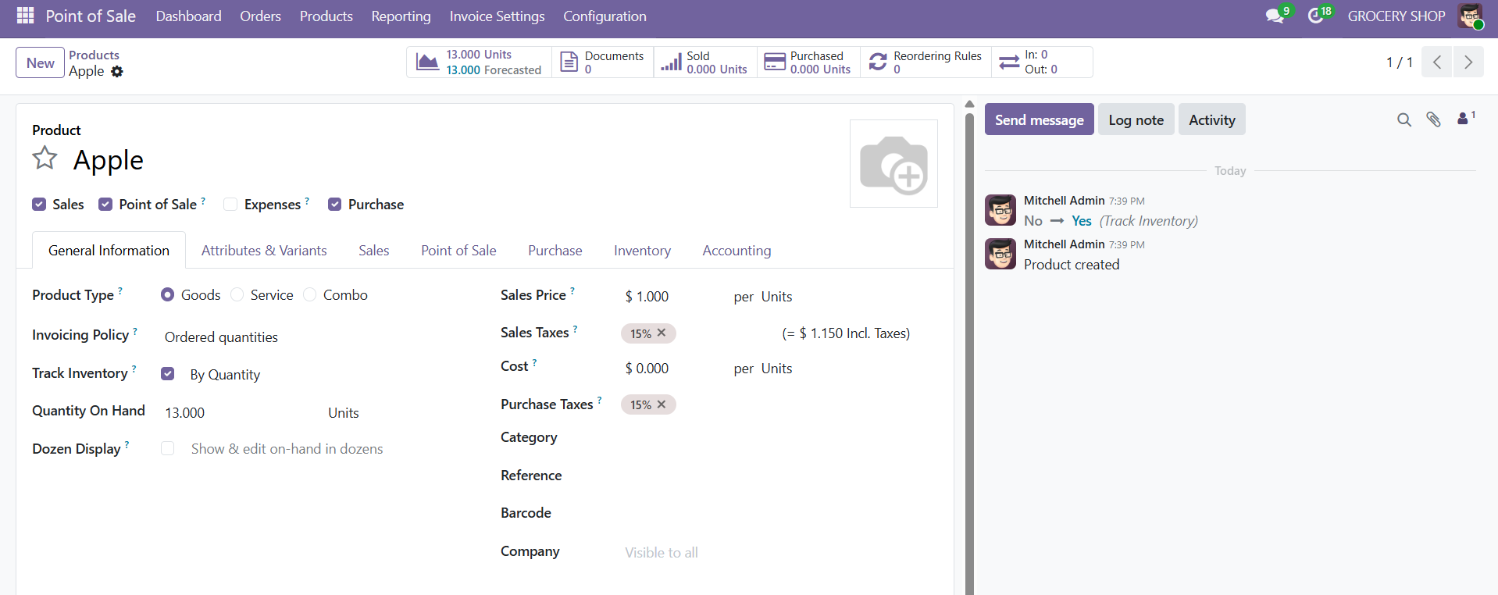
Figure 3: Turn on Track Inventory — the Dozen Display checkbox appears under Quantity On Hand.
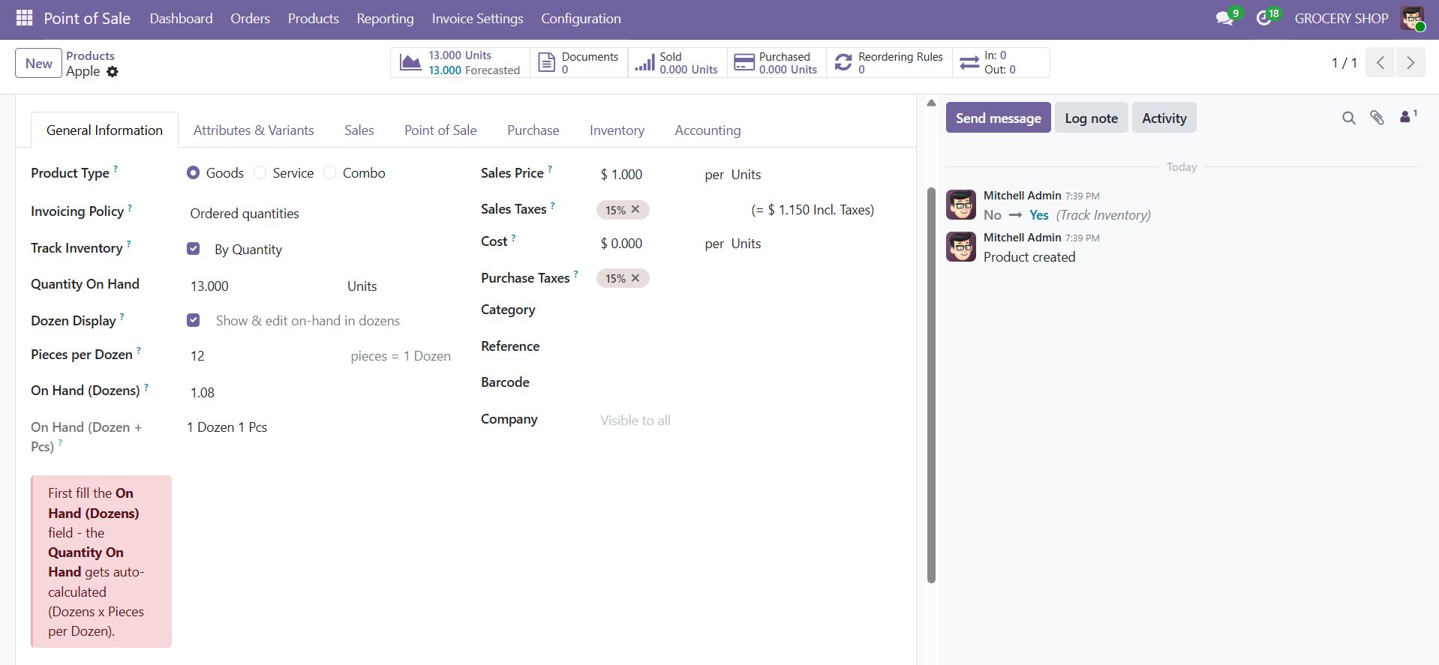
Figure 4: Tick Dozen Display — the dozen fields appear (13 pieces with a 12-piece pack reads 1 Dozen 1 Pcs).

4.2 Set Pieces per Dozen
In Pieces per Dozen, enter how many single pieces make one dozen for this product. It defaults to 12, but you can set any value (for example 6 or 15). Every conversion for this product uses it.
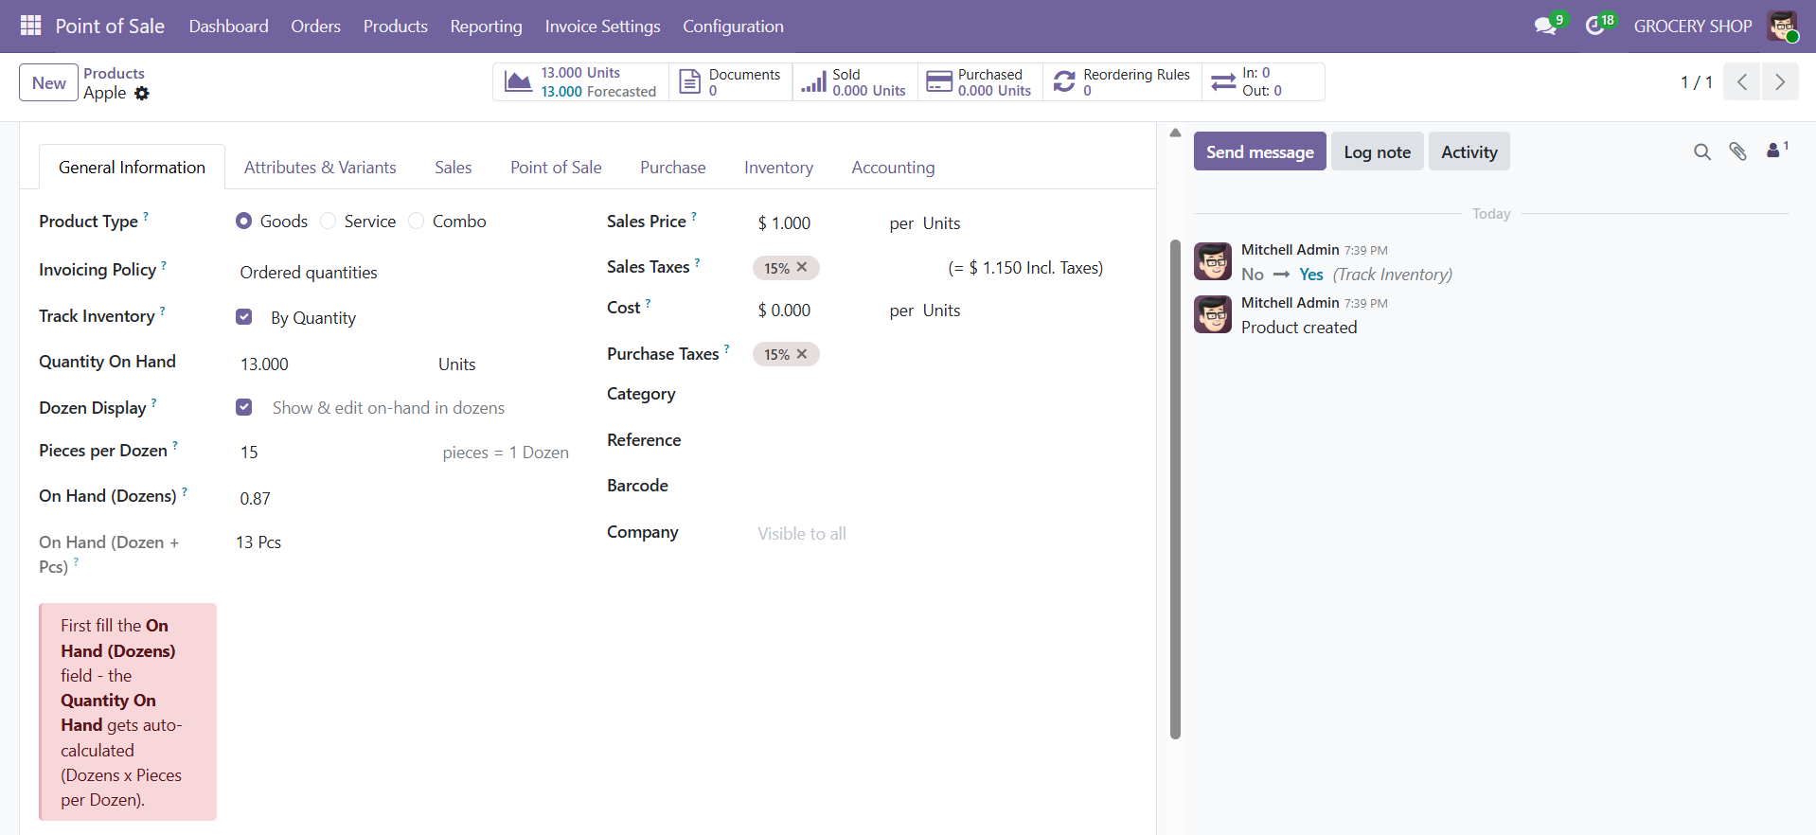
Figure 5: Changing Pieces per Dozen to 15 recalculates every dozen field instantly — the same 13 pieces now read 13 Pcs (0.87 dozens).
TIP Each product has its own pack size — eggs can be 12 while another item is 6 or 15.

4.3 Enter the on-hand quantity in dozens
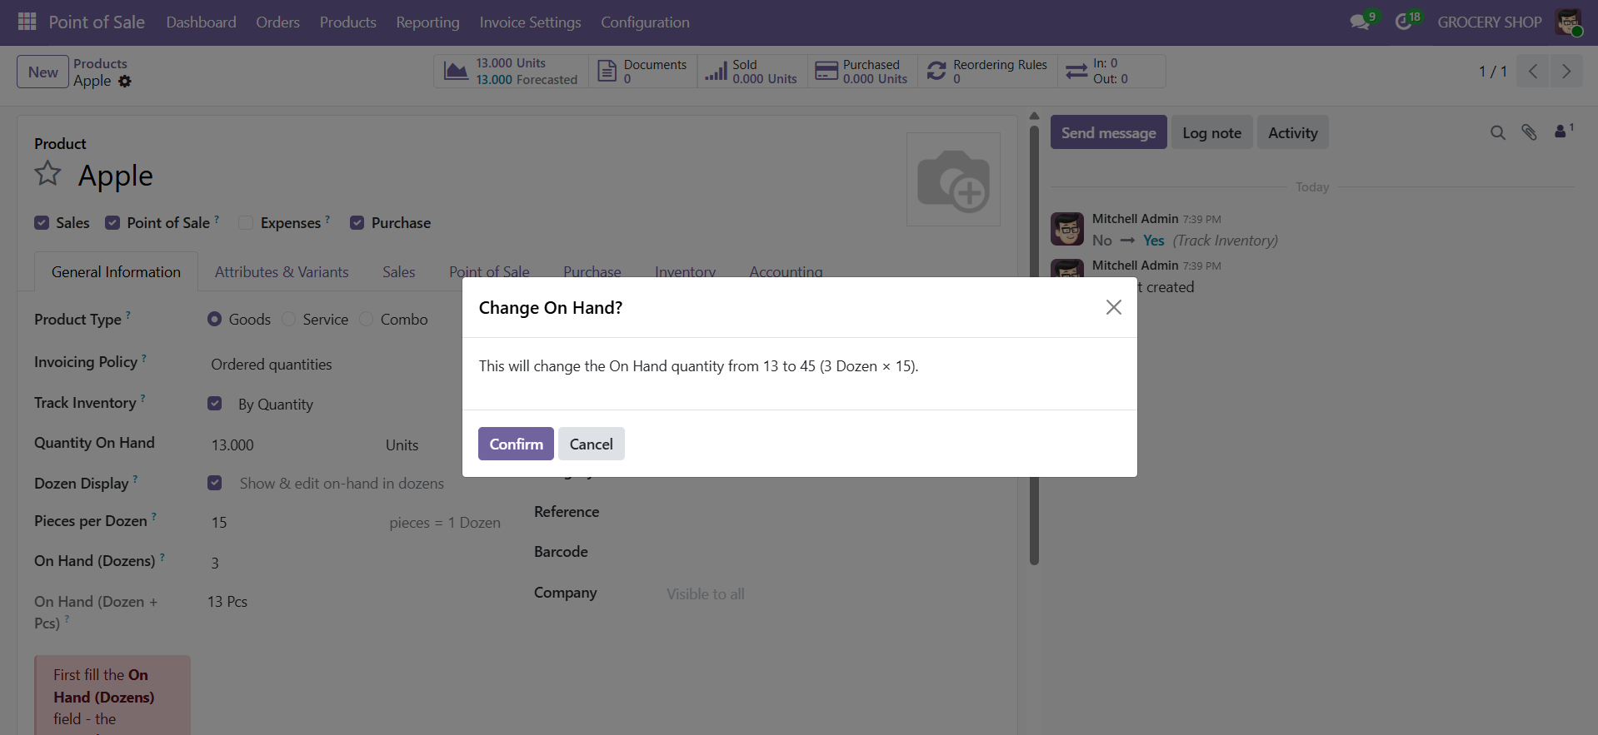
Figure 6: Type 3 in On Hand (Dozens) — a popup asks you to confirm the change from 13 to 45 pieces (3 Dozen × 15).
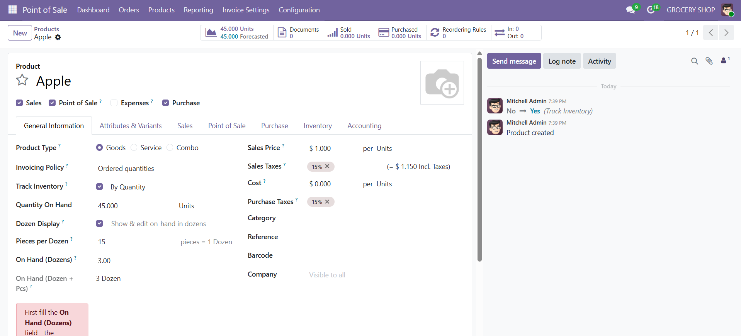
Figure 7: After confirming, Quantity On Hand becomes 45 and the breakdown reads 3 Dozen.
NOTE The confirmation appears only when your entry actually changes the current Quantity On Hand. Re-typing the same value does not prompt.

4.4 Read the on-hand breakdown
On Hand (Dozen + Pcs) shows the current stock as full dozens plus the loose remainder (for example “9 Dozen 7 Pcs”), and On Hand (Pieces) shows the same stock as a total piece count. The “Dozen + Pcs” value also appears as a column on the products list.

4.5 Count in dozens during an inventory adjustment

5. Troubleshooting
Symptom | Cause & fix
The Dozen Display checkbox is missing. | The product must be storable (Track Inventory on) and measured in the Units family. Hard-refresh the browser after installing or upgrading.
The dozen fields do not appear after ticking the checkbox. | Save is not required, but a stale browser can hide them — do an empty-cache reload (Ctrl+Shift+R).
Quantity On Hand shows dozens, not pieces. | The product's Unit of Measure is “Dozens”. Set it to “Units” if you want Quantity On Hand counted in single pieces.
The confirmation popup does not show. | The widget did not load — do an empty-cache reload so the browser fetches the latest assets.
The screenshots below show the "Quantity On Hand shows dozens, not pieces" situation on a product whose Unit of Measure is set to Dozens:
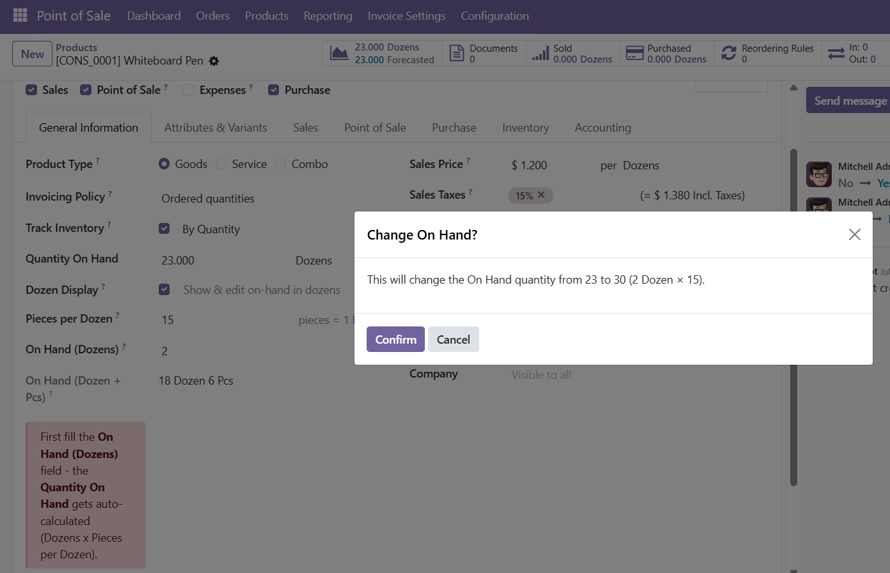
Figure 8: Entering 2 in On Hand (Dozens) with a 15-piece pack — the popup correctly confirms the change to 30 pieces (2 Dozen × 15).
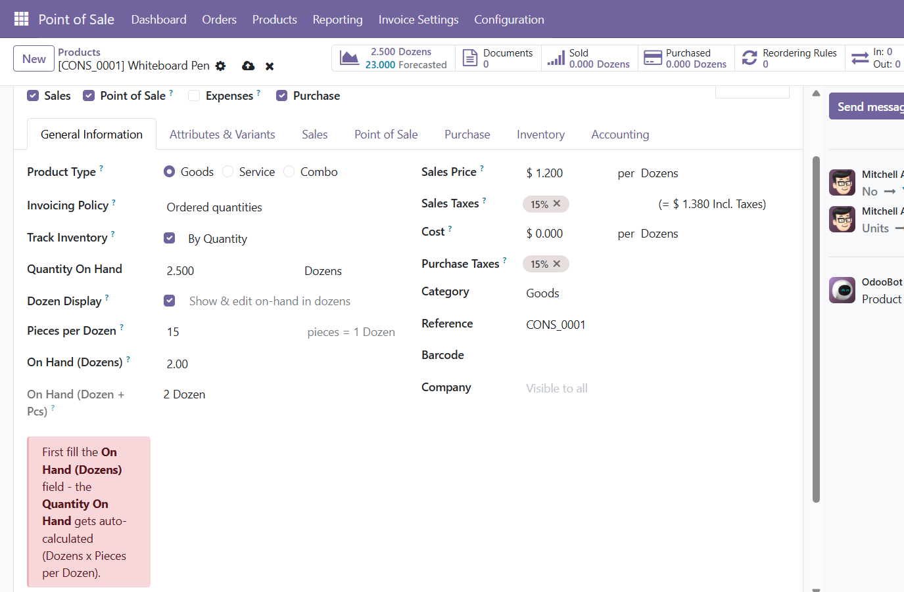
Figure 9: Because this product’s Unit of Measure is Dozens, the confirmed 30 pieces display as "2.500 Dozens" in Quantity On Hand — set the UoM to Units to count in single pieces.

Appendix A: Quick Reference

Where to find things
Item | Location
Dozen fields | Product form › General Information, under Quantity On Hand
Dozens unit | Inventory › Configuration › Units of Measure
Counted (Dozens) | Product › On Hand / inventory-adjustment list

At a glance
Action | Result
Tick Dozen Display | Dozen fields appear for the product
Set Pieces per Dozen = 12, type 10 dozens | Quantity On Hand = 120
On hand = 115 pieces (pack 12) | On Hand (Dozen + Pcs) = “9 Dozen 7 Pcs”

